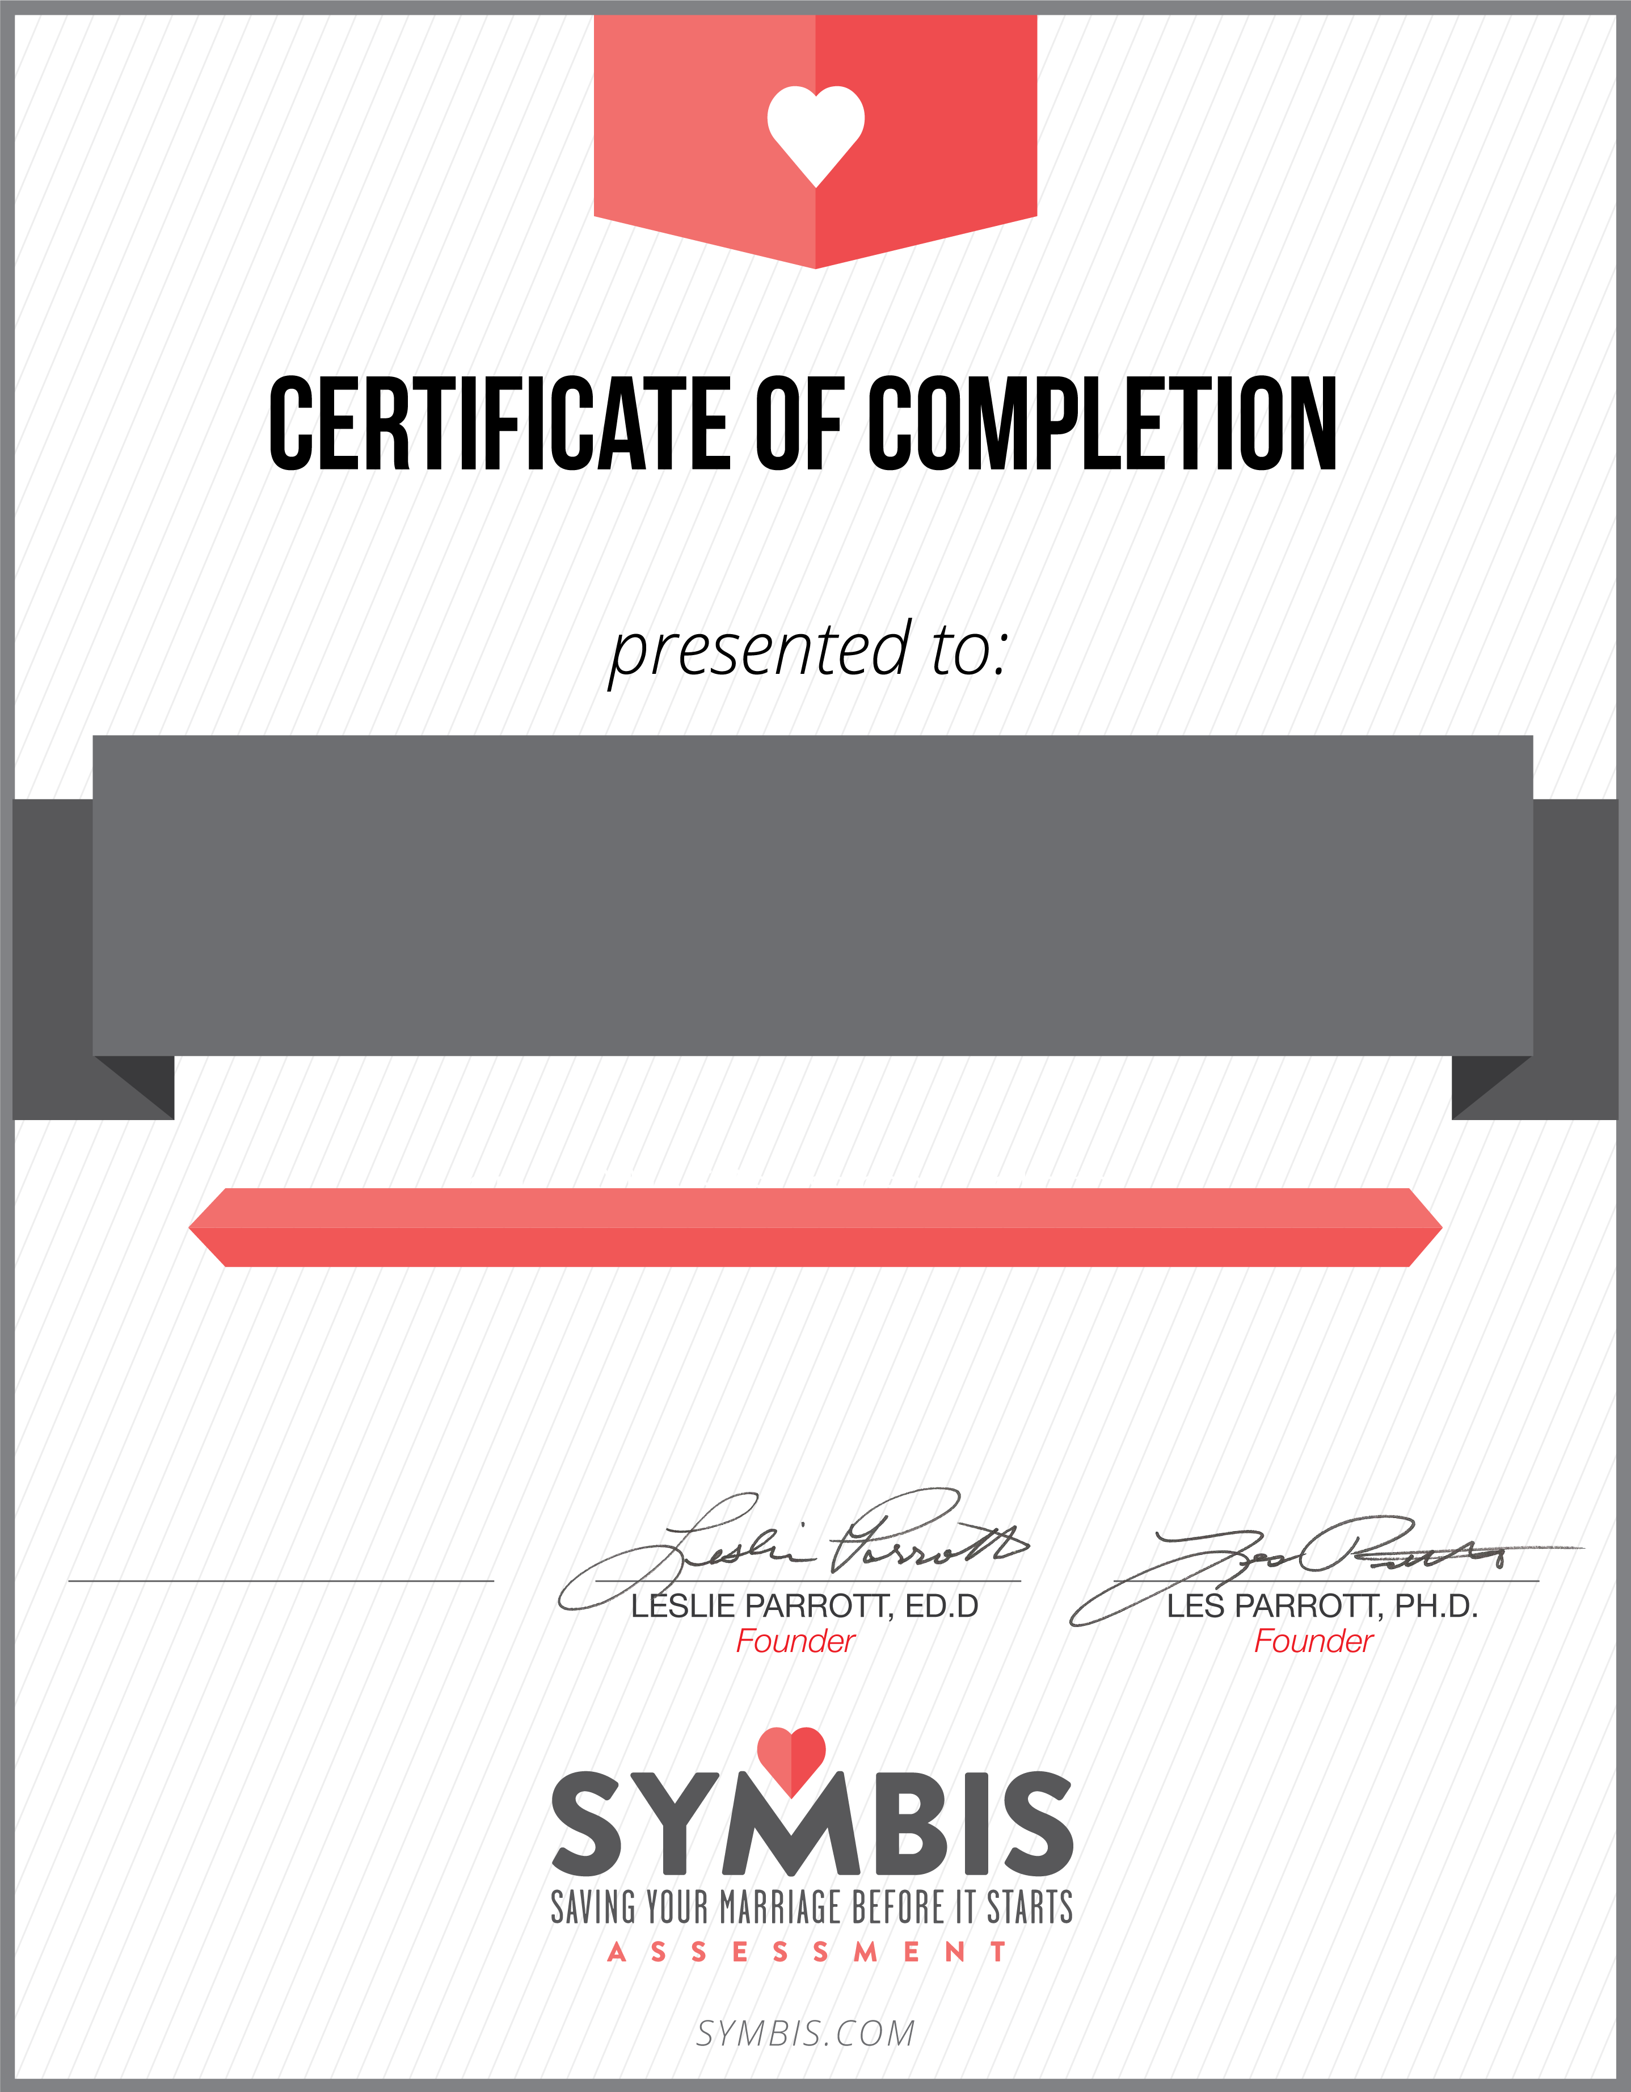

Carol Lynne

*I Tie The Knots Weddings*

On Month & Day, 2023, the above named couple completed our church’s pre-marriage program including the completion of the SYMBIS Assessment. It is our prayer for them to enjoy a lifetime of love together.

Carol Lynne, Facilitator

Pre-Marriage Course

Your Names Here